# Config Watcher

## Scope

This guide explains the basic purpose of Config Watcher.

Config Watcher is intended to be run at intervals to snapshot new configuration applied to a Geo SCADA database.

## Running Config Watcher

Start the program from the Start menu. Later, you may use a scheduler to run the program from its location in Program Files. After displaying the splash screen, the main window will be shown as below.

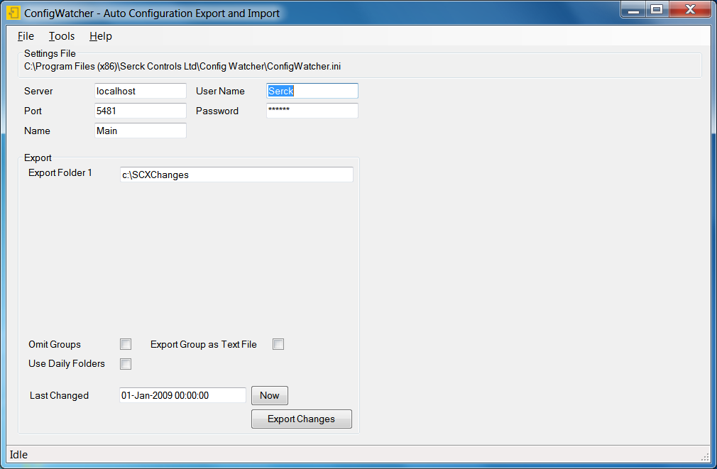

Config Watcher uses configuration files (extension .ini) to store options. The default file is placed in the folder of the ‘.exe’ file and is named ‘ConfigWatcher.ini’.

The name of the current file is shown at the top of the window. Use the ‘File’ menu to load, create and save these files.

The fields on the window are described below:

Server: The IP address or computer name of the server.

Port: The port number which database clients use.

Name: The client connection name which ViewX clients use to connect to this database.

User Name: The username with database access. The account used should have configure access to all areas of the database. No other privilege is needed. It is not recommended to use an administrator level account.

Password: The password for the above account. This password is stored in plain text in the ‘.ini’ settings file. Means of protecting access to this file for unauthorised users must be implemented as required.

Export Folder 1: This is the name of the folder into which modified configuration files will be exported. There is no ‘\’ at the end of this path.

Omit Groups: If not ticked, then any detected change to a Group, Template group or Template Instance group will cause both the group **and all of its children** to be exported too. This is not desirable. It is recommended to tick this option, and these groups will not be exported with their children.

Export Group as Text File: When ‘Omit Groups’ is ticked, this option is available. When ticked it will cause an export of a text file which indicates that the group has changed, and if a template instance the number of the template object is contained in the text file. It is recommended to tick this option.

Use Daily Folders: When ticked, exports will be placed in a folder which is named with the date of the export (not the date that the object was changed). If used for recording changes over a long period, this option should be ticked.

Last Changed: The modification date of all objects in the database are compared against the date in this field. To start exporting changes from a particular date, enter the date in this field. Click ‘Now’ to insert the current date and time into this field. When the process has run, this field is automatically changed to the latest modification date found, so that each process will only find new changes.

Export Changes: This will execute the data comparison and export process.

Note that in the Tools menu, there is an Advanced option which displays many more fields. These are not documented here.

## Scheduling Config Watcher

Config Watcher is simple to schedule via the command line. Any scheduling program can be used. The command line arguments specify the configuration file to be used. For example:

<Path>\ConfigWatcher.exe "ExportChanges" "c:\CWSettings\MySettings.ini"

## Output File Format and Name

Files are either in ‘.sde’ format, suitable for import into SCX, or are in ‘.txt’ file format, containing the group object name and, if applicable, the template instance Id number.

Filenames are of the form:

<SCX Object Name>+<TypeName>+<ConfigVersionNo>+<ConfigDateTime>+<ConfigUser>

Long file names are truncated from the right to 250 characters. Including the file path, the maximum length is 254 characters. Object names can be long, so it is recommended that the folder for export files is a short folder name, e.g. ‘D:\Changes’.